**ARUSHA TECHNICAL COLLEGE**

****

**ELECTRICAL ENGINEERING DEPARTMENT**

**A PROJECT REPORT**

**ON**

**AUTO CUT OFF AIR-CONDITIONER SYSTEM IN ABSENCE OF PEOPLE AND WHEN AIR ENTRANCE ARE LEFT OPEN**

*Submitted by*

**ELIA WILLIAM MARIKI**

**ADM NO: 19030802008**

**NTA LEVEL 6**

*Under the guidance of*

**ENG. ISACK NKOLA**

*In* *partial fulfillment for the award of the*

**ORDINARY DIPLOMA OF ENGINEERING**

**IN**

**ELECTRONICS AND TELECOMMUNICATION ENGINEERING**

2022

# DECLARATION

I, Elia Willam Mariki, with admission number 19030802008 a student of Diploma in Electronics and Telecommunication Engineering at Arusha Technical College, I would like to declare that the project report entitled AUTO CUT OFF AIR-CONDITIONER SYSTEM IN ABSENCE OF PEOPLE AND WHEN AIR ENTRENCE ARE LEFT OPEN submitted by me in partial fulfillment of the requirements for the completion of my Diploma original work and efforts.

Student’s Signature: …………………. Supervisor’s Signature: ……………….…

Student name: ELIA.W. MARIKI Supervisor(s) Name: Eng. Isack Nkola

Date: ……………………………….... Date: …………………………………....

**ABSTRACT**

This project report introduces the designing and implementation of AUTO-CUT OFF AIR-CONDITIONER SYSTEM IN ABSENCE OF PEOPLE AND WHEN AIR ENTRANCE ARE LEFT OPEN It has been designed with the aim of ensuring that air conditioner is used in such a way that it will last long without damage and thus will enable the user to spend less on its maintenance and even repair it in the event of any defect.

This project is very important because it enables the air conditioner to turn itself off without any supervision only when it is clear that the doors and windows are open, can it also detect the presence of people in the room and enable it to turn on and can also be turned off when it detects that there is no people in the room.

The whole system will include various devices such as sensors that can detect if the air entrance is open or the presence of people in the room and will be able to make decisions automatically as the system shuts down or turns on based on the instructions it will have inside.

**ACKNOWLEDGEMENT**

During this project, several people have provided many forms of help and support. Firstly, I would like to thank Electrical Department faculty members for allowing me to do this project and for continuous guidance throughout the project. Secondly, I would like to thank the other members who have provided ideas, been cooperative, and made the work so well. There have been no occasions where a conflict of opinion has not been resolved successfully. Great thanks towards my college Supervisor Eng. Isack Nkola and project coordinator Eng. Daniel Malaya for his support throughout the project

TABLE OF CONTENTS

[DECLARATION i](#_Toc106407828)

[ABSTRACT ii](#_Toc106407829)

[ACKNOWLEDGEMENT iii](#_Toc106407830)

[CHAPTER ONE 1](#_Toc106407831)

[1.0 INTRODUCTION 1](#_Toc106407832)

[1.1 General Introduction 1](#_Toc106407833)

[1.2 Problem Statement 1](#_Toc106407834)

[1.3 Project Objectives 2](#_Toc106407835)

[1.3.1 Main objective 2](#_Toc106407836)

[1.3.2 Specific objectives 2](#_Toc106407837)

[1.4 Significance of the project 2](#_Toc106407838)

[1.5 Project scope 3](#_Toc106407839)

[CHAPTER TWO 4](#_Toc106407840)

[2.0 LITERATURE REVIEW 4](#_Toc106407841)

[2.1 Introduction 4](#_Toc106407842)

[2.2 Existing System 4](#_Toc106407843)

[2.3 Block Diagram of Existing System 4](#_Toc106407844)

[2.4 The Proposed System 5](#_Toc106407845)

[2.6.1 Operation of the proposed system 6](#_Toc106407846)

[CHAPTER THREE 7](#_Toc106407847)

[METHODOLOGY 7](#_Toc106407848)

[3.1 Introduction to Methodology 7](#_Toc106407849)

[3.2 Literature review 7](#_Toc106407850)

[3.3 Data Collection 7](#_Toc106407851)

[3.4 Data analysis 7](#_Toc106407852)

[3.5 Circuit Designing and Simulation 7](#_Toc106407853)

[3.6 Implementation and Testing 7](#_Toc106407854)

[CHAPTER FOUR 8](#_Toc106407855)

[DATA COLLECTION AND DATA ANALYSIS 8](#_Toc106407856)

[4.1 Introduction to Data Collection 8](#_Toc106407857)

[4.1.1 Primary Data 8](#_Toc106407858)

[4.1.2 Secondary Data 10](#_Toc106407860)

[4.1.2.1 System units power ratings 10](#_Toc106407861)

[4.1.2.2 Motion Detecting sensor 11](#_Toc106407862)

[4.1.2.3 Temperature and Humidity Sensor 12](#_Toc106407863)

[4.1.2.4 Switching Unit 13](#_Toc106407864)

[4.1.2.5 Microcontroller 14](#_Toc106407866)

[4.2 Data Analysis 15](#_Toc106407869)

[4.2.1 Switching unit 15](#_Toc106407870)

[4.2.2 Microcontroller 16](#_Toc106407871)

[4.2.3 Temperature Sensor 18](#_Toc106407872)

[4.2.4 Motion Detecting Sensor 19](#_Toc106407873)

[4.2.5 Power Supply Segment 20](#_Toc106407874)

[4.2.5.1 Calculating the Transformer Ratio 20](#_Toc106407875)

[4.2.5.2 Calculation on Rectifier Output 21](#_Toc106407876)

[4.2.5.3 Design of a Filter 21](#_Toc106407877)

[4.2.5.4 Design of a Regulator 22](#_Toc106407878)

[4.3 Circuit Designing 23](#_Toc106407879)

[4.3.1 Schematic Circuit Diagram 23](#_Toc106407880)

[CHAPTER FIVE 25](#_Toc106407881)

[CONCLUSION AND RECOMMENDATION 25](#_Toc106407882)

[5.1 CONCLUSION 25](#_Toc106407883)

[5.2 RECOMMENDATION 25](#_Toc106407884)

[APPENDICES 26](#_Toc106407885)

[REFERENCES 28](#_Toc106407886)

**LIST OF FIGURES**

[Figure 4.1 Bar chart representing AC users’ suggestions 10](#_Toc106408268)

[Figure 4.2 PIR sensor 12](file:///C:\\Users\\OWEN\\Desktop\\ELIA%20WILLIAM%20MARIKI%2019030802008%20SES%2002%20edited.docx" \l "_Toc106408269)

[Figure 4.3 Thermistor 12](file:///C:\\Users\\OWEN\\Desktop\\ELIA%20WILLIAM%20MARIKI%2019030802008%20SES%2002%20edited.docx" \l "_Toc106408270)

[Figure 4.4 Relay 14](file:///C:\\Users\\OWEN\\Desktop\\ELIA%20WILLIAM%20MARIKI%2019030802008%20SES%2002%20edited.docx" \l "_Toc106408271)

[Figure 4.5 ATmega 328P 15](file:///C:\\Users\\OWEN\\Desktop\\ELIA%20WILLIAM%20MARIKI%2019030802008%20SES%2002%20edited.docx" \l "_Toc106408272)

[Figure 4.7 16MHz crystal oscillator and 22pf ceramic capacitors 18](#_Toc106408273)

[Figure 4.8: LM7805 Pin configuration 22](#_Toc106408274)

[Figure 4.9 Schematic Circuit diagram 23](file:///C:\\Users\\OWEN\\Desktop\\ELIA%20WILLIAM%20MARIKI%2019030802008%20SES%2002%20edited.docx" \l "_Toc106408275)

**LIST OF TABLES**

[Table 4.1 A Table Showing List of Questions Asked to 20 Different Ac Users 8](#_Toc106408424)

[Table 4.2: system units’ power ratings 11](#_Toc106408425)

[Table 4.3 Technical specifications of PIR sensor 11](#_Toc106408426)

[Table 4.4 Technical Specifications of Relay 13](#_Toc106408427)

[Table 4.5 ATmega 328P Properties. 14](#_Toc106408428)

[Table 4.6 Switching devices and their specifications 15](#_Toc106408429)

[Table 4.7: Microcontroller and Their Technical Characteristics 16](#_Toc106408430)

[Table 4.8 Sensing devices and their specifications 19](#_Toc106408431)

[Table 4.9 Power Requirement in The Circuit 20](#_Toc106408432)

**CHAPTER ONE**

1. **INTRODUCTION**
   1. **General Introduction**

Auto-cut off air-conditioner system in absence of people and when air entrances are left open is an electronic system designed mainly for the protection purpose of an air conditioner. Where the system will be able to control the status of air conditioner automatically by checking the factors for proper working of the air conditioner.

It will be able to check if any of air entrance are left open and also check if there is presence of people in a room. If any of air entrance left open it will turn off the air conditioner until it has been closed, also if there is presence of people inside a room it will turn on the air conditioner and turnoff if there is no one inside the room.

The system will never turn on if any of the conditions does not meet.

In many offices tends to control the switching operation of the air conditioner manually, but when they only need to do so but they don’t consider the best factors or good environment for preservation of the air conditioner.

* 1. **Problem Statement**

Leaving the window and door open gives a lot of work to air conditioner to cool the indoor air because it let warm air get inside the room.

further increase of outside air in the room in a period air conditioner is working may cause the air conditioner to become damaged since the compressor required to work so much harder than normal to regulate the inside Temperature.

Also leaving the air entrance open the entire night causes a large amount of moisture to enter the room. This further burdens the air conditioner during the day as it tries to get the room cool and get rid of humidity.

As this works cyclically, you will find that it takes a longer time to get cool air during the day because the air conditioner is doing a lot, most of the air conditioner seems to have a small lifespan but not because of the manufacture quality.

It because of the user ignorance to follow the instruction on how to use the air conditioner for the best performance, this results in damaging it in a short period of time.

Power consumption: air conditioner tends to use high power when it is used beyond its control or gives it a staggering task to do this means that when the outside air enters the room at the same time the air conditioner work so much to cool the air inside the room uses a lot of power in contrast to its normal state as it works extra apart from its normal condition.

### **1.3 Project Objectives**

The following are the project objectives

### 1.3.1 Main objective

The main objective of this project is to design and implement Auto-cut off air-conditioner system in absence of people and when air entrances are left open

### 1.3.2 Specific objectives

The following are the specific objectives that will be taken to achieve the main objective.

* To design the circuit of proposed system
* To simulate the control circuit using simulation software.
* To implement and test system prototype
  1. **Significance of the project**
* Implemented device will simplify switching processes of Air-conditioner since operation will be carried out automatically.
* It reduces power consumption.
* It gives the air conditioner a long life without damage.
* It is the best system that can overcome negligence that can be done by anyone who can forget to turn off the air conditioner when he leaves and closes the office.
* It is a very affordable system that most people can afford in their daily use.
* It is not a payment system so after it is implemented by engineer the system becomes yours automatically.
  1. **Project scope**

The system will be built by following every single procedure so as avoid any malfunction problems. Both the hardware and software parts will be carefully checked. The system will be able to operate in the size of one room or office or any of size (125-225 square feet per person).

**CHAPTER TWO**

**LITERATURE REVIEW**

* 1. **Introduction**

In this chapter, the related or existing systems and technologies, their block diagrams and disadvantages, the proposed system and its advantages will be discussed also it will involve the

gathering of information from different sources like website, internet, books, and other ideas from teachers about the existing system.

* 1. **Existing System**

The existing system known by the name AN AUTOMATIC TEMPERATURE CONTROLLED SWITCH FOR AIR CONDITIONING SYSTEMS. Where it has only one function of detecting value of the current temperature status and turning on either the air conditioner or heater. In its operation the design has three operational states in which when air- conditioner ON room-heater OFF, room-heater ON air- conditioner OFF, and air-conditioner OFF room-heater OFF designated as state 1, state 2 and state 3 respectively. In addition to these states of operation, it has sensitivity control that allows for manipulation of the design in order to support ergonomic, that is, it can be made to remain in the first two states for as long as desired, vary the operating temperature of the two devices and be retained in the third state when the ambient temperature is 25oC.

## **2.3 Block Diagram of Existing System**

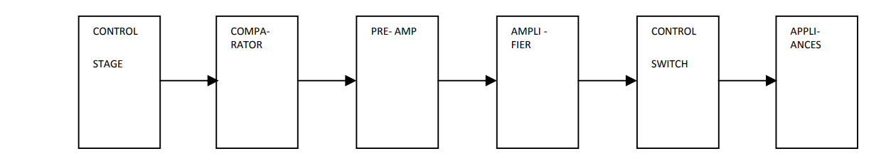

Figure 2.1: Functional block diagram**. (**Aboaba et al., 2015**)**

The limitation of this project it deals with only detection of temperature variation as well as make decision to turn on either heater or air conditioner, but is not able to detect if any of the air entrance is left open and make any decision. Also the creator of this project failed to see if the abandonment of open air entrances is a major problem affecting the air conditioner and leading to damage and makes it difficult for air conditioner to cool the indoor air conditioning.

Disadvantages of a current system

1. Does not detect if the air entrance of the room if are open or not.
2. It cause the air conditioner damage over short period time because it only detect the environmental temperature and turn the air conditioner in a high speed for cooling without checking the causes of the rise in that temperature.
3. The system need so many maintenance and calibration of sensors.

## **2.4 The Proposed System**

The system will be able to detect the presence of person and detect if any of air entrance left open or closed, and turn on or off the air conditioner depending on the system instruction given.

It will also be able to monitor the temperature in the room and enable the system to turn on the air conditioner or turn it off due to the user's need for the air conditioner.

This system will also be able to turn on the heater when the temperature is found to be lower than the user's needs.

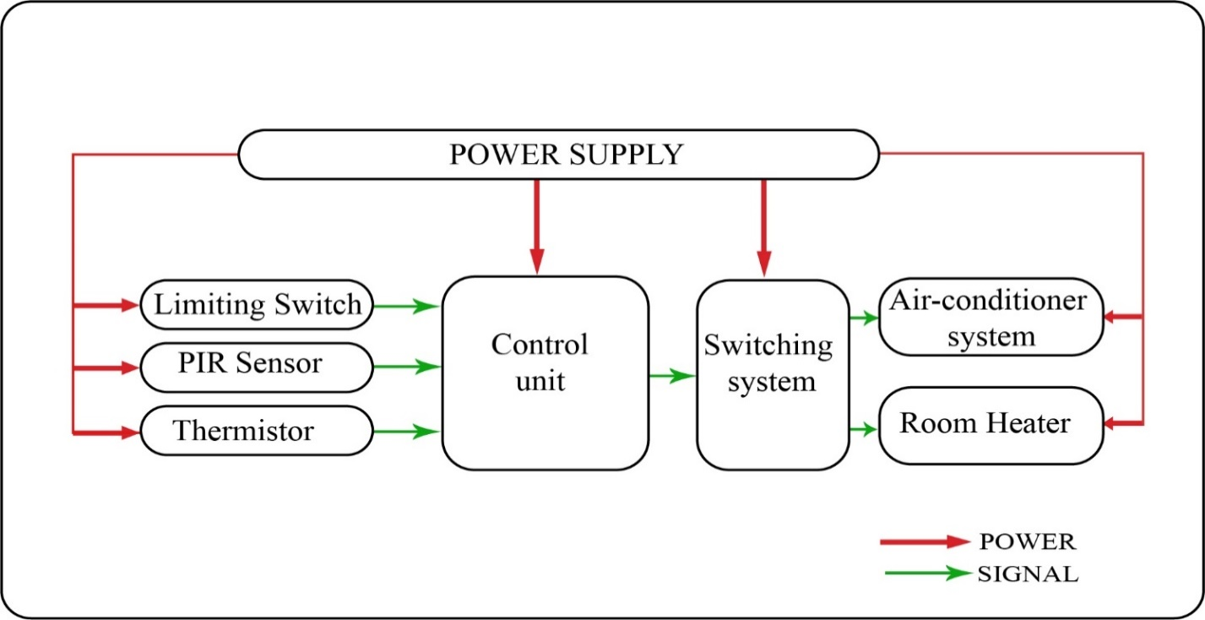

Figure 2.2: Block diagram of a proposed system

**2.6.1 Operation of the proposed system**

The control Unit is the main unit that will be receiving different input signals from sensors (PIR sensor, Temperature sensor and Limiting sensor). Due to the instruction given the control unit will switch the relays to either turn the air conditioner ON and OFF.

All of these devices will be powered with different voltage where the air conditioner will be switched either on or off with relay 220VAC while the control unit and sensors requires only 5Vdc.

Advantages of proposed system

1. It reduces power consumption.
2. It gives the air conditioner a long life without damage.
3. Is the best system that can overcome negligence that can be done by anyone who can forget to turn off the air conditioner when he leaves and closes the office.
4. It is a very affordable system that most people can afford in their daily use.

**CHAPTER THREE**

**3.0 METHODOLOGY**

**3.**1 **Introduction to Methodology**

This chapter describes different steps that will be taken to accomplish the objective of designing an **Auto-Cut Off Air Conditioner System in Absence of People and When Air Entrance Are Left Open** by performing some management methods to keep this project stand on the right track. To ensure the project prototype successfully developed, some tasks must be performed by following different sequences of work. The following are the steps that will be taken to accomplish the objectives of the project;

**3.2 Literature review**

Apart from electrical and electronic books, through the internet and based on what others have done will help to widen the knowledge and to know how the procedures must be followed to achieve the goals of the project.

**3.3 Data Collection**

On the way, towards the accomplishment of this project important data about the currently existing system and currently available equivalent components and the proposed system will be gathered as collected from different relevant sources.

**3.4 Data analysis**

All the collected data will be carefully analyzed to identify which component will suit the system design.

**3.5 Circuit Designing and Simulation**

The circuit will be designed in the proteus software to see how the connection will it be before the implementation. After designing the circuit will be simulated by compiling the program and feed it into the circuit in proteus software to observe the output.

**3.6 Implementation and Testing**

The designed and simulated circuit is then implemented on the strip board. After implementation, the testing will be done to obtain the required output and to meet the objective of the project.

### **CHAPTER FOUR**

# 4.0 DATA COLLECTION AND DATA ANALYSIS

## **4.1 Introduction to Data Collection**

Data collection is defined as systematic gathering of data for particular purpose from various sources like questionnaires, interviews, and observation and existing records. Data collection have been divided into two parts; primary and secondary data collection. Finding out information on the existing system, the need for the proposed system and parameters required for the proposed system are also considered in this part.

## **4.1.1 Primary Data**

These are the type of data which are collected directly from the different offices concerning the problems arising due to. System Primary data were collected by interviewing different expected system users and doing some observations. In this system, primary data I collected from various methods such as questionnaires and observation from AC users.

In case of questionnaire data were collected from various AC users including office people, saloons as well as supermarkets. The questions were asked to 20 people and their answers are as shown in the table below

Table 4.1 A Table Showing List of Questions Asked to 20 Different Ac Users

|  |  |  |  |  |
| --- | --- | --- | --- | --- |
| **NO** | **QUESTIONS** | **ANSWERS** | |  |
| YES | NO | NEUTRAL |
| **1** | Is your AC consuming large number of electrical units per day? | 13 | 7 | - |
| **2** | Are you considering terminating AC use because of the Operating costs incurred? | 8 | 12 | - |
| **3** | Have you ever tried to leave AC ON for a long period of time? | 12 | 7 | 1 |
| **4** | Have you repaired your AC within 4 months? | 14 | 6 | - |
| **5** | Have you used more than three ACs since you started using AC? | 7 | 13 | - |
| **6** | Is the proposed system favorable to the user? | 16 | 4 | - |
| **7** | Will the proposed system conserve power? | 17 | 3 | - |
| **8** | Will the proposed system solve the problem? | 13 | 3 | 4 |
| **9** | Will the proposed system reduce cost? | 18 | 2 | - |
| **10** | Do you think the proposed system will be a better technology to be installed? | 11 | 3 | 5 |

Figure 4.1 Bar chart representing AC users’ suggestions

Conclusively, from list of questions are bar chart it seems that there is a need of system that will be able to cut off Air Conditions when doors and windows are left open. AC seems to consume large power hence in case it is not in use it should be OFF to save power as well as cost.

## **4.1.2 Secondary Data**

Secondary data are data collected from different sources of information like books, magazine, articles, and from any other existing systems that relates to the proposed system. It includes the components for the circuit;

### **4.1.2.1 Motion Detecting sensor**

This is the one of the input device of the system which gives indication of movement of people to the room. Motion detecting sensors are of various types these are; PIR sensor and IR sensor, Ultrasonic sensor.

Passive Infrared Sensor (PIR) is a motion detector which detects the infrared heat energy emitted naturally by humans and animals when a person in the field of vision of the sensor mode, the sensor detects sudden change in infrared energy and the energy is activated. PIR sensor are opposite of IR sensors that emit energy, such as ultrasound, light, or microwaves.

The term passive in this manner refers that the PIR devices do not generate or radiate any energy for the detection purposes. They work entirely by detecting the energy given off by other objects. PIR sensors don’t detect or measure heat instead they detect the infrared radiation emitted or reflected from a body.

Table 4.2 Technical specifications of PIR sensor

|  |  |
| --- | --- |
| Parameters | Values |
| Supply Voltage | 3V to 5V |
| Detection range | 2-3 meters |
| Temperature range | -15C to +70C |
| Current range | Less than 50µA |

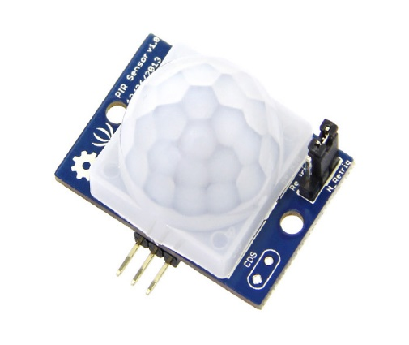

Figure 4.2 PIR sensor (**Senith Electronics,2019**)

**Features:**

* Compact size
* Voltage drop: high/low level signal(O-3v)
* High sensitivity Infrared sensor: dual element, low noise
* Light sensor: compounds photocell

### **4.1.2.2 Temperature and Humidity Sensor**

This sensor is used in system to measure the temperature of the room and compares to the threshold set value so as to enable switching ON and OFF air-condition. There are numerous types of temperature sensors which can be used, these are LM35, DHT 11, DHT 22, Thermostat, Thermocouple, Thermistor, TMP 100, LM 75, and D6T. However, on the proposed system Thermistor is used.

Table 4.3 Sensing devices and their specifications

|  |  |  |  |
| --- | --- | --- | --- |
| Specifications | LM 35 | THERMISTOR | DHT SENSOR |
| Operating current(µA) | 70 | 60 | 2.5 |
| Operating Voltage(V) | 4-20 | 5 | 5 |
| Temperature range | -55C to 150C | 0-100C | 0-50C |

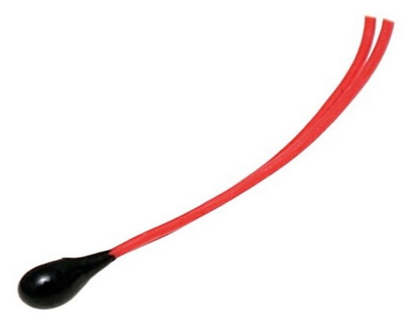

Figure 4.3 Thermistor (**Allied Electronics, 2019)**

**Specifications:**

* Temperature -50 to 150
* Accuracy 0.2K
* Length 50mm,100mm,150mm as standard
* Diameter 6mm
* Body temperature 174°C

### **4.1.2.3 Switching Unit**

Switching unit is used in the system to switch air condition ON and OFF. Switching unit can be RELAY, TRIAC, and MOSFET TRANSISTOR.A relay is an [electrically](https://en.wikipedia.org/wiki/Electric" \o "Electric) operated [switch](https://en.wikipedia.org/wiki/Switch" \o "Switch). It consists of a set of input terminals for a single or multiple control signals, and a set of operating contact terminals. Relays are used where it is necessary to control a circuit by an independent low-power signal, or where several circuits must be controlled by one signal.

Table 4.4 Switching devices and their specifications

|  |  |  |
| --- | --- | --- |
| Specifications | TRANSISTOR | RELAYS |
| Operating current(mA) | 40 | 40 |
| Operating Voltage(V) | 3.75 - 5 | 3.75 |
| Power(mW) | 150 - 200 | 150 |

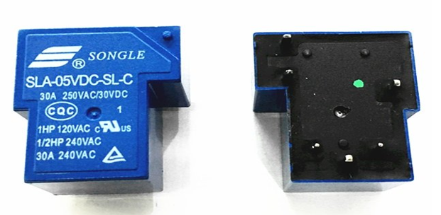

Figure 4.4 Relay (**Electro Schematics, 2019)**

### **4.1.2.4 Microcontroller**

### The system includes a controller which will be controlling the input and output modules. For the system to a reliable and more efficient, the most efficient and reliable control unit should be selected. The table below shows different controllers that may suit the system designing with their distinctive features and key parameters. Different types of microcontroller such as AT80S52, PIC16690, ATmega 16, and ATmega 328P. In this system ATmega 328P is used to control conditions set.

Table 4.3 Microcontroller units and their technical specifications

|  |  |  |  |  |
| --- | --- | --- | --- | --- |
| Specifications | AT89S52 | PIC16690 | ATmega16 | ATmega328P |
| I/O pins | 32 | 18 | 32 | 28 |
| Operating voltage (V) | 4.0-5.5 | 4.0-5.5 | 4.0-5.5 | 4.0-5.5 |
| Operating Frequency | 33MHz | 20MHz | 16MHz | 16MHz |
| Architecture | RISC | RISC | RISC | RISC |

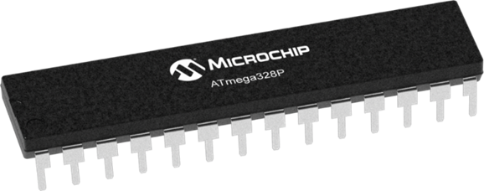

Figure 4.5 ATmega 328P (**Microchip Tech,2018**)

## **4.2 Data Analysis**

### **4.2.1 Switching unit**

Switching devices includes any mechanical, electrical, pneumatic or hydraulic device designed to open or close electrical circuit. A switch is need in this project so as to accomplish the switching OFF and ON air condition when people are not present at the room surroundings. Transistor and relay were alternatives to the switching unit. There are compared in the table below;

**Reasons to Choose Relay as Switching Unit**

* It is operating using low voltage in this system, a 5V 6-in Relay is used as a switching device since it meets the load requirement in terms of voltage and current ratings.
* Low power consumption. The load rating expected is about 230V and 0-30A.
* It has long life span

### **4.2.2 Microcontroller**

The system includes a controller which will be controlling the input and output modules. For the system to a reliable and more efficient, the most efficient and reliable control unit should be selected.

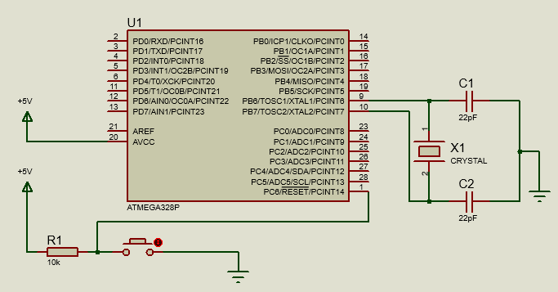

Figure 4.6 ATmega 328P circuit diagram

**4.2.2.1 Selection of Parasitic Capacitor**

The Proposed system the microcontroller used to control the switching unit and other input and output devices. The controller should have two analog input pins for the current sensor, and voltage measuring unit, three digital pins for the GSM module, and the switch.

In this system, ATmega 328P is a good choice since it has all the required features required for the system.

Formula to calculate external load capacitance of an oscillator

Where;

𝐶L is the load capacitance

𝐶STRAY is the shunt capacitance of the oscillator.

Now;

Assuming C1=C2=C then:

From the ATmega328 datasheet,

Ranges from to

Also, from crystal oscillator datasheet,

{For 8MHz crystal}

Therefore; -

The Parallel resonant crystal′s external load capacitor is 22pf for 16MHz

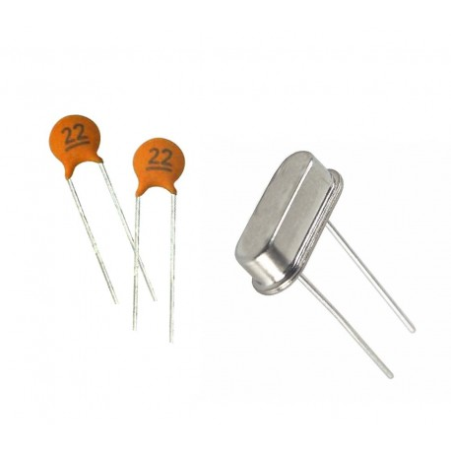

Figure 4.7 16MHz crystal oscillator and 22pf ceramic capacitors (**Circuit Digest, 2022**)

The A/D converter of Atmega328p is 10-bit and the measuring current of the circuit is 30 A

(Ranging from −30 to +30) A. From the above data (Tables 5.2 and 3), the quantization noise of the A/D converter can be calculated by Equation below.

Where: *QN*: quantization noise; *IM*: measuring range; N: A/D bits of the converter

### **4.2.3 Temperature Sensor**

In this project the Thermistor is used to measure the temperature of the surroundings and leading to the switching of the system when temperature is high and switch OFF when temperature is low. These are inputs devices which measure physical parameters of something and compares to the set value and sends feedback to the controller. Temperature as parameter that has to be monitored and maintained with the help of temperature sensing device. There are numerous types of temperature sensors whose specifications are compared on the table below;

**Reasons to Choose Thermistor**

* Quick temperature change detection
* It is cheap
* Small in size
* Long range detection

### **4.2.4 Motion Detecting Sensor**

In this project PIR sensor is used for detection purpose if there is anyone inside the room. It does detection process whatever there is movement appeared inside the room and at the range in which the sensor can work.

**Reasons to Choose PIR Sensor**

* The PIR sensor has a smaller body size and also it’s lighter in weight.
* The operating voltage of both sensors is from 3 to 5 volts, while the max current used when measuring is less 50uA.
* Also its Compact size, Voltage drop: high/low level signal (O-3v),
* High sensitivity Infrared sensor: dual element,
* Low noise
* Light sensor: compounds photocell

### **4.2.5 Power Supply Segment**

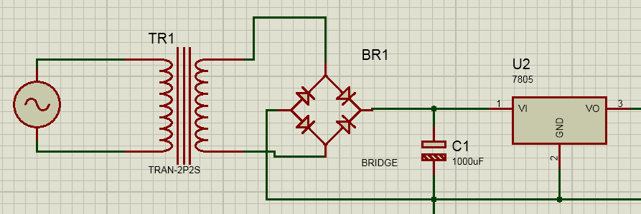In power supply segment, the power value to each part of the circuit leading to the completeness of the project will be revealed.

Figure 4.7 Power Supply circuit diagram

To convert 230V/50Hz into +5V/0Hz requires step by step design from input to the output. These steps are transformer, regulator, and filter.

### **4.2.5.1 Calculating the Transformer Ratio**

Electrical energy at primary coil= electrical energy at secondary coil

Where, Vp= Voltage at primary coil =240V, Ip = Current at primary coil

Vs= Voltage at secondary coil = 12V, Is= Current at secondary coil

Np= Number of turns in primary coil, Ns= Number of turns in secondary coil

= =

= 20

Hence, ratio of number of primary turns to the secondary turns are 20

### **4.2.5.2 Calculation on Rectifier Output**

The output voltage of the secondary coil of step down transformer is fed to the input of bridge rectifier.

From

Vrms =

Vpeak = Vrms x

But Vrms = Vs= 12V

Then Vpeak of the secondary coil= x 12V

=16.97V

Considering potential drop of two diodes in forward bias since 16.97V will be applied into bridge rectifier. The potential barrier is 0.7V for each diode.

Output of bridge rectifier (Vout) = 16.97V – 1.4V

Output of bridge rectifier (Vout) = 15.57V

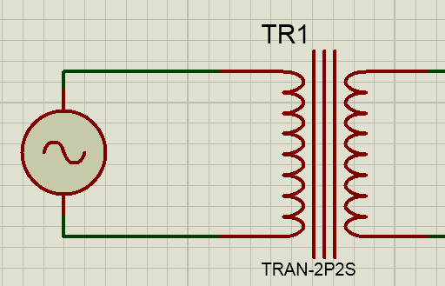

Figure 4.8 Transformer schematic diagram

### **4.2.5.3 Design of a Filter**

A filter is the portion of the power supply that removes all the ripples components of the output signal of the bridge rectifier. For the linear power supply the rectifier is a suitable capacitor that filters the DC signals. The ripple factor equation is suitable to design the filter.

Where; f= Frequency of AC (50 Hz), R=Resistance calculated, =Ripple factor

From Ohm’s law V=IR

From equation R=

, R=33.9

Assume the Ripple factor in DC signal is 7%

From equation

, Where f=50Hz

Capacitance of capacitor is 1216.5µF

The chosen standard capacitance of a capacitor is 1000µF

### **4.2.5.4 Design of a Regulator**

A regulator is the electronic device that provides constant output voltage regardless of the change in the input voltage or load conditions.

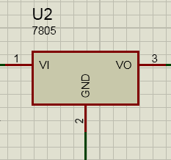

Figure 4.9 LM7805 Pin configuration

## **4.3 Circuit Designing**

### **4.3.1 Schematic Circuit Diagram**

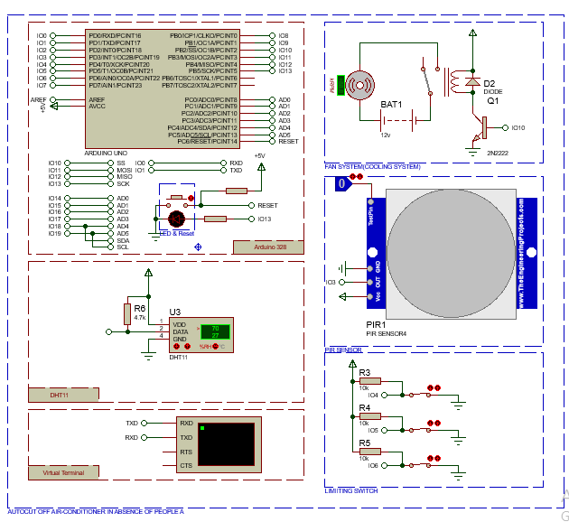This part deals with how every component analyzed from the previous part will fit to create an entire system. Different parts of the circuit were interfaced together and simulated on Proteus so as to excel objectives of the project.

Figure 4.10 Schematic Circuit diagram

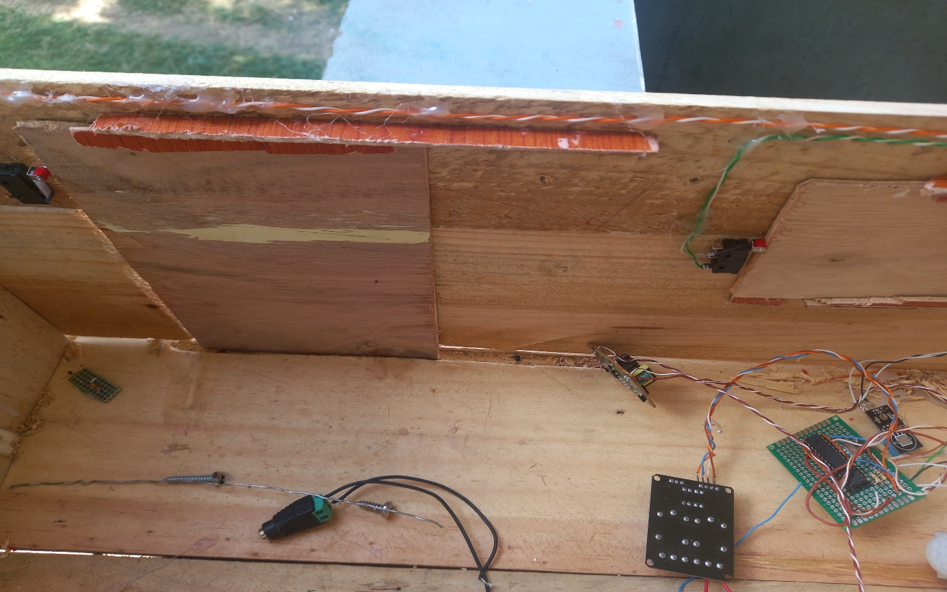

Figure 4.11 Top view of the prototype

Figure 4.11 Back view of the prototype

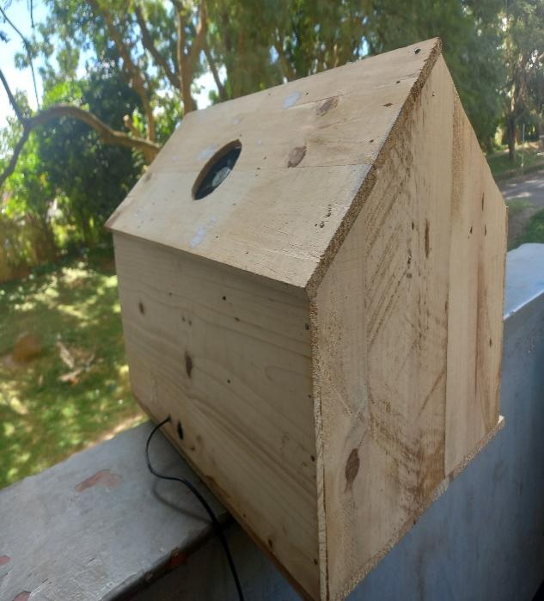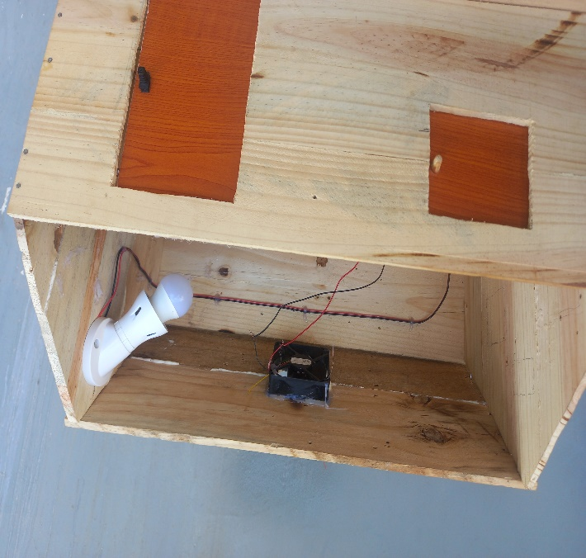

Figure 4.13 Back view of the prototype

Figure 4.12 Front view of the prototype

# CHAPTER FIVE

# 5.0 CONCLUSION AND RECOMMENDATION

## **5.1 CONCLUSION**

Main objective of the project was to design and implement Auto-cut off air-conditioner system in absence of people and when air entrances are left open. Designed system was able to cut-off air condition when people are not present and when windows and doors are left open.

## **5.2** **RECOMMENDATION**

The presented system is among of the technological advanced project that if taken into consideration would save cost as well as minimizing use of large power. Air conditions are one of known electrical equipment in consuming large power and in developing countries such as Tanzania electrical power should be used much in economic activity such as industrialization to promote economic growth hence advancement of this project is going to save cost for both national and individuals.

# 

# REFERENCES

1. Aboaba A.A., Amoo A & Lukman A. (2015). “Design of an automatic Temperature controlled switch for air-conditioner system” .ResearchGate .Retrieved Feb.04, 2022. <https://www.researchgate.net/publication/290605733_DESIGN_OF_AN_AUTOMATICTEMPERATURE_CONTROLLED_SWITCH_FOR_AIRCONDITIONING_SYSTEMS>
2. Kengi,A..J (2019) *Mechanism and function of HVAC, VENTILATOR, HEATER,and AC, ATOMATIC AIR* <http://www.kengilbert.com//>
3. GA.ASHRAE. (1992) “.*American Society of Heating, Refrigeration and Air-Conditioning Engineers, Atlanta”*
4. HVAC Systems and Equipment Handbook
5. . Munters Cargocaire, Ames-bury, MA.Pesaran, A.A., Penny, T.R., and Czanderna. 1992. *Dehumidiﬁcation Handbook Second Edition*
6. . Desiccant Cooling: State-of-the-Art Assessment.
7. Copenhagen.Zheng, W., Worek, W.M., and Novosel, D. 1993 .National Renewable Energy Laboratory, Golden, CO.United Nations Environmental Programme. 1992” *Report of the fourth meeting of the parties to theMontreal protocol on substances that deplete the ozone layer”*
8. Collier, R.K, Cale, T.S., and Lavan, Z. “Chap. 19. American Society of Heating, Refrigeration andAir Conditioning , Desiccant properties and their effect on cooling system performance”

# APPENDICES

**APPENDIX A.**

**//Sample of Arduino code for auto cut off system when air entrances are left open**

#define pir 3

#define fan 10

#define switch0 4

#define switch1 5

#define switch2 6

#define LM A1

void setup() {

Serial.begin(9600);

pinMode(switch0 ,INPUT);

pinMode(switch1,INPUT);

pinMode(switch2,INPUT);

pinMode(LM,INPUT);

pinMode(pir,INPUT);

pinMode(fan,OUTPUT);

Serial.println("LECOIN ELECTRONICS");

}

void loop()

{

int First\_state=digitalRead(switch0);

int Second\_state=digitalRead(switch1);

int Third\_state= digitalRead(switch2);

float Fourth\_state=analogRead(LM)/2.08;

int PIR\_READINGS=digitalRead(pir);

Serial.println(Fourth\_state);

if(PIR\_READINGS==HIGH)

{

if(First\_state==LOW){

if(Second\_state==LOW)

{

if(Third\_state==LOW)

{

if(Fourth\_state>=25)

{

digitalWrite(fan,HIGH);

delay(100);

}

else{digitalWrite(fan,LOW);}

}

else{digitalWrite(fan,LOW);}

}

else{digitalWrite(fan,LOW);}

}

else{digitalWrite(fan,LOW);}

}

else{digitalWrite(fan,LOW);}

}